SCREENSHOTS OF DASHBOARDS

1.AWS login page with username:

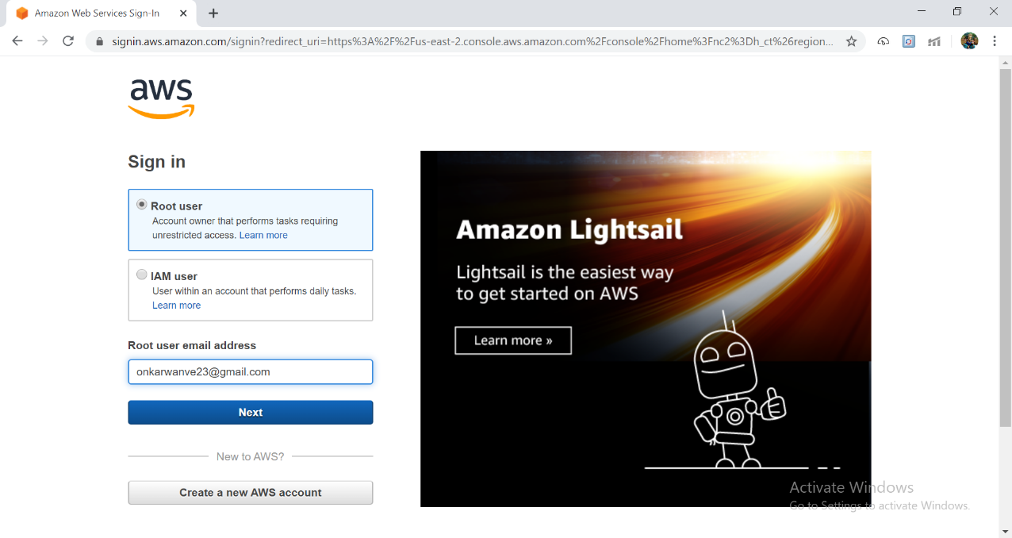

2. EC2 Dashboard:

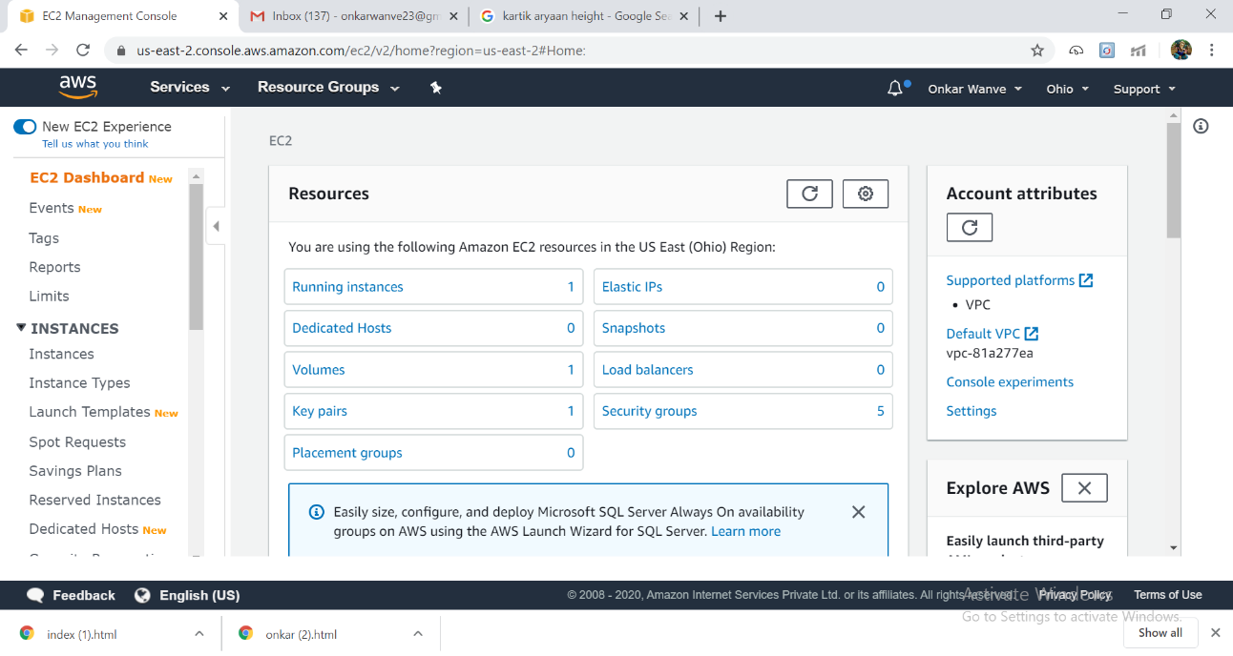

3.S3 Dashboard:

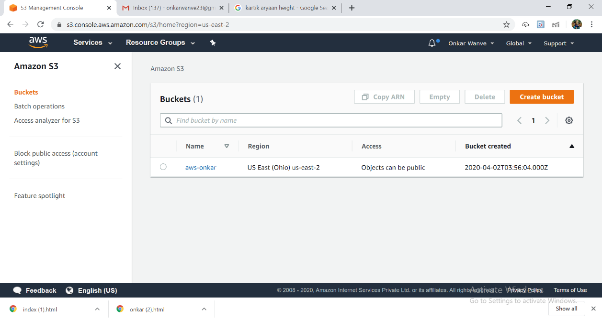

4.Recognition Dashboard:

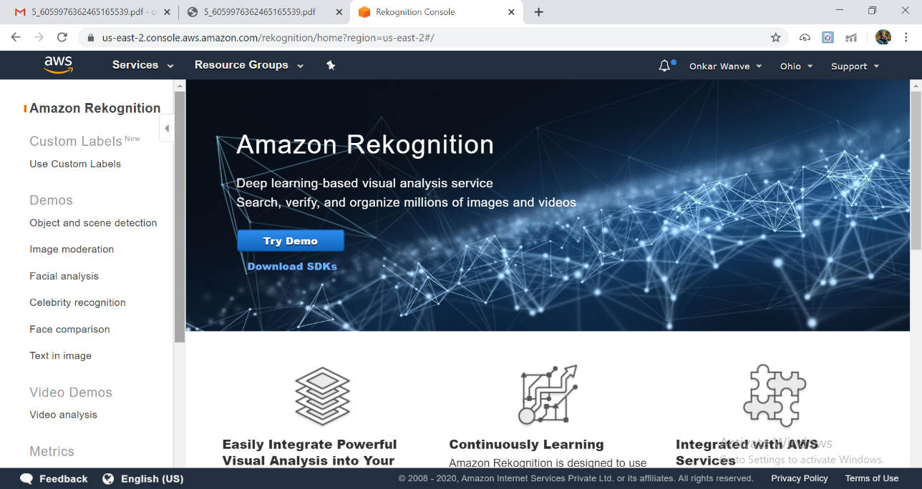

SCREENSHOT OF EC2

1.Choosing an AMI:

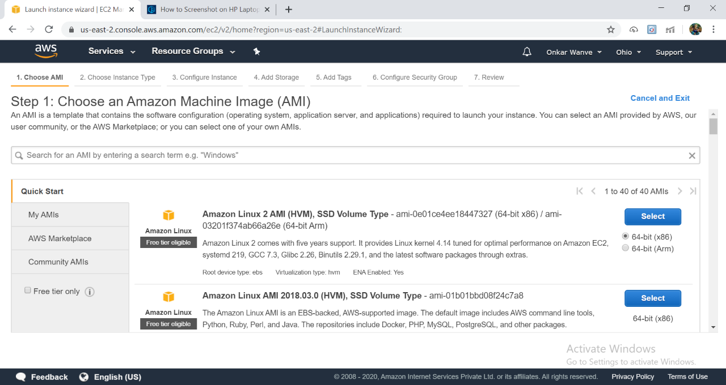

2.Choosing an instance type:

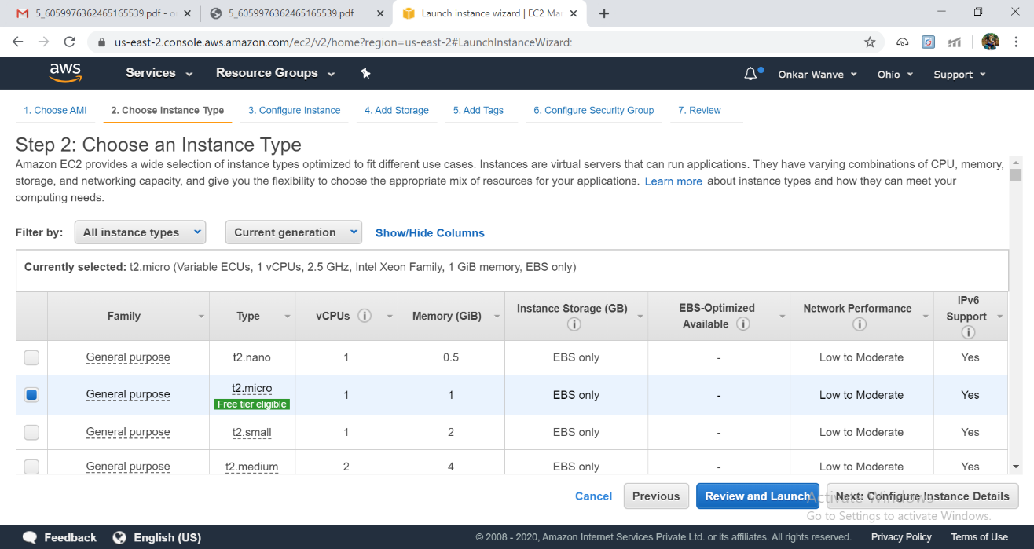

3.Adding Storage:

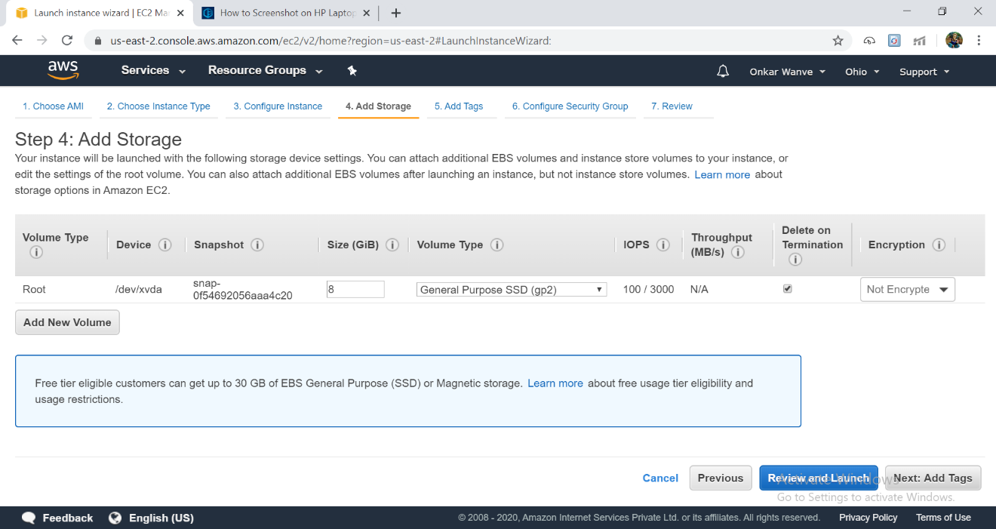

4.Configuring Security Group:

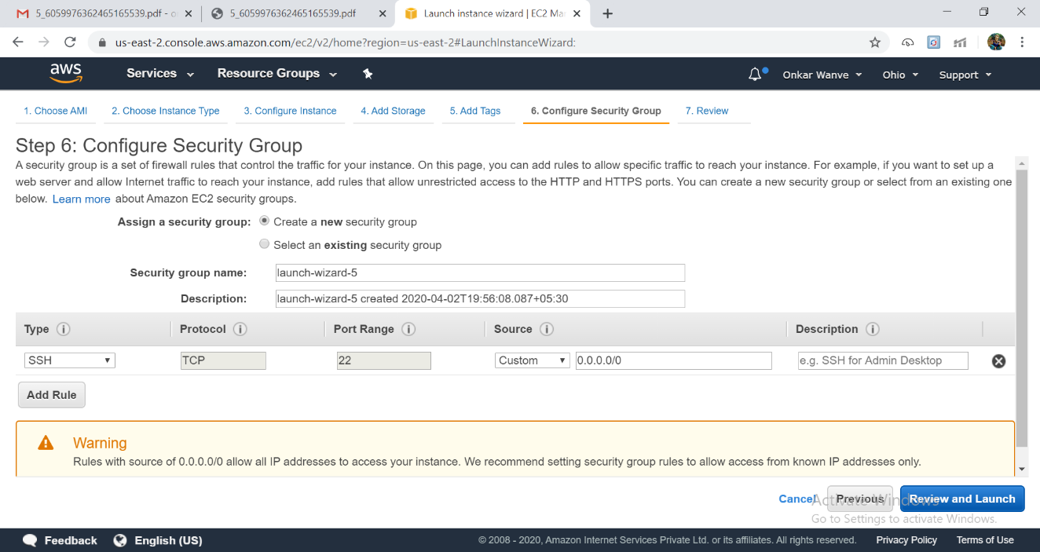

5.Key pair:

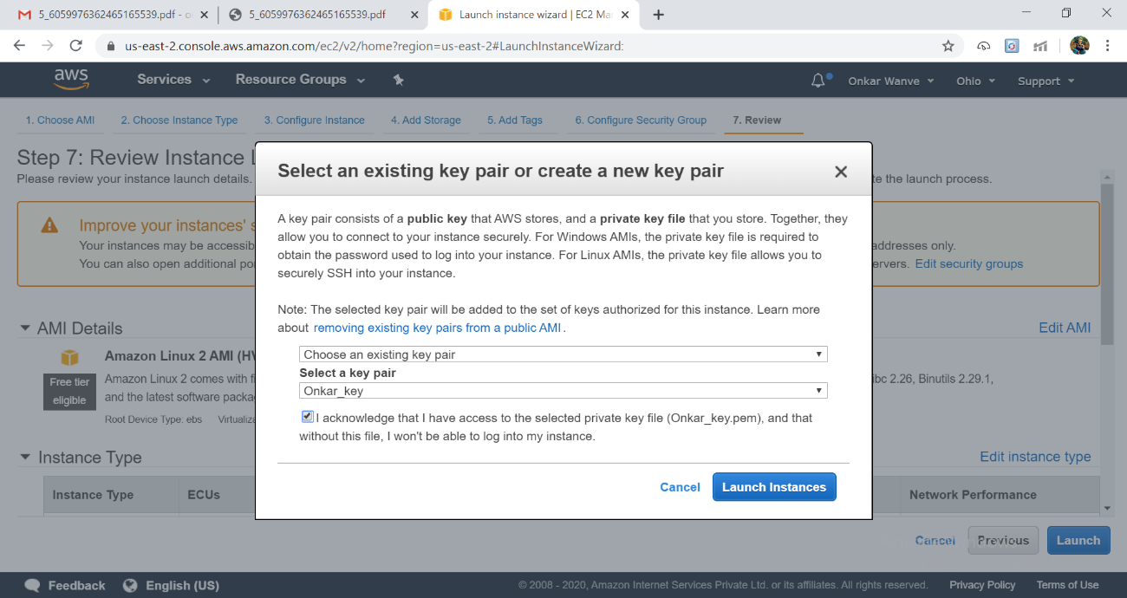

6.Logged in EC2 blank Screen:

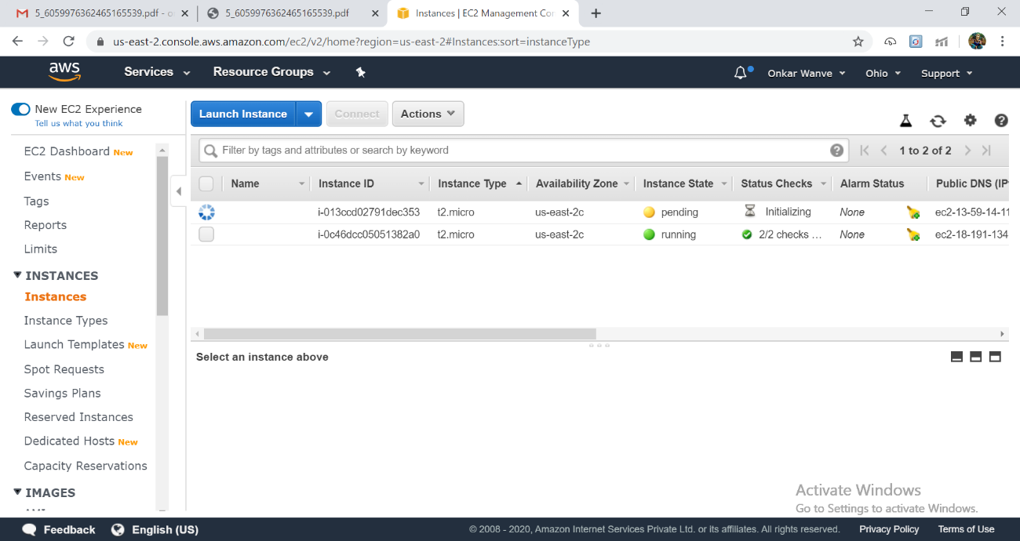

SCREENSHOTS OF S3

1.Creating a Bucket:

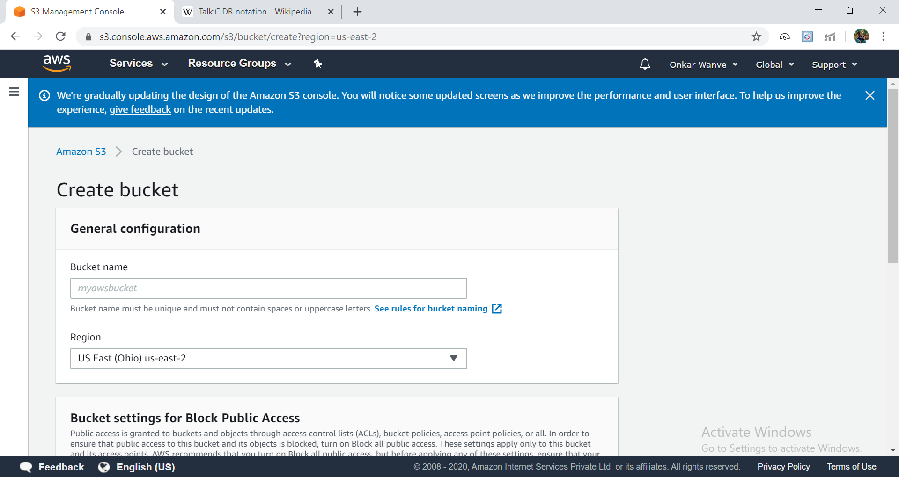

2.Uploading an object:

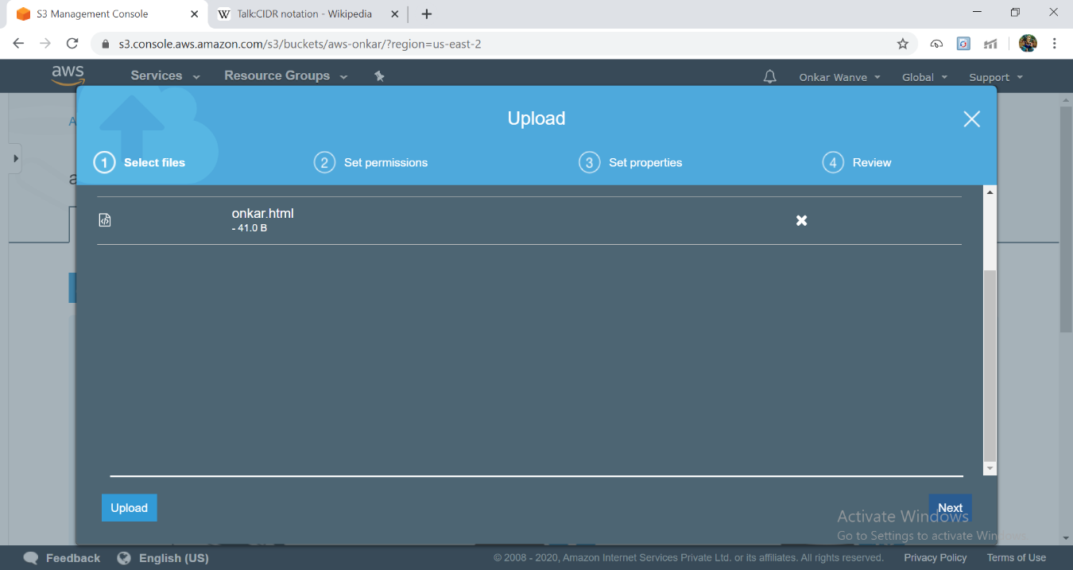

3.Enabling Static Website:

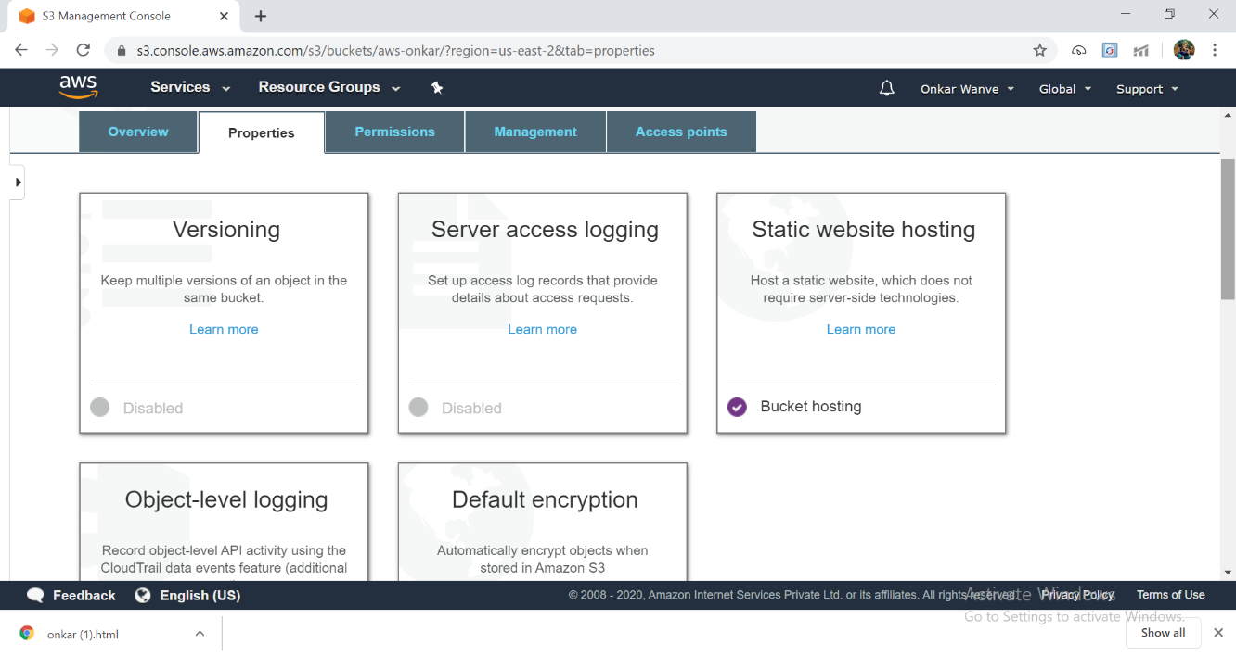

4.Making the Object Public:

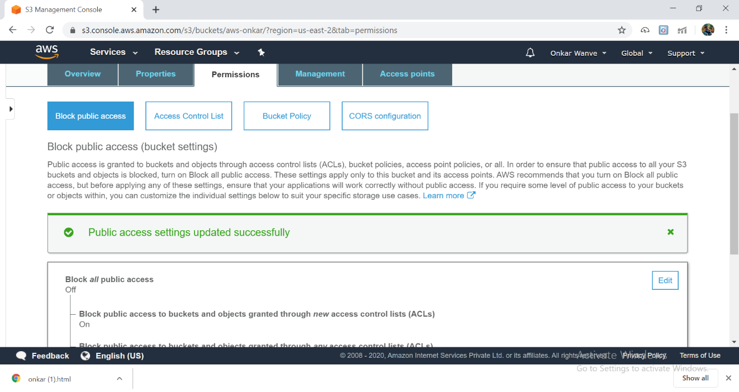

5.Checking S3 link on browers:

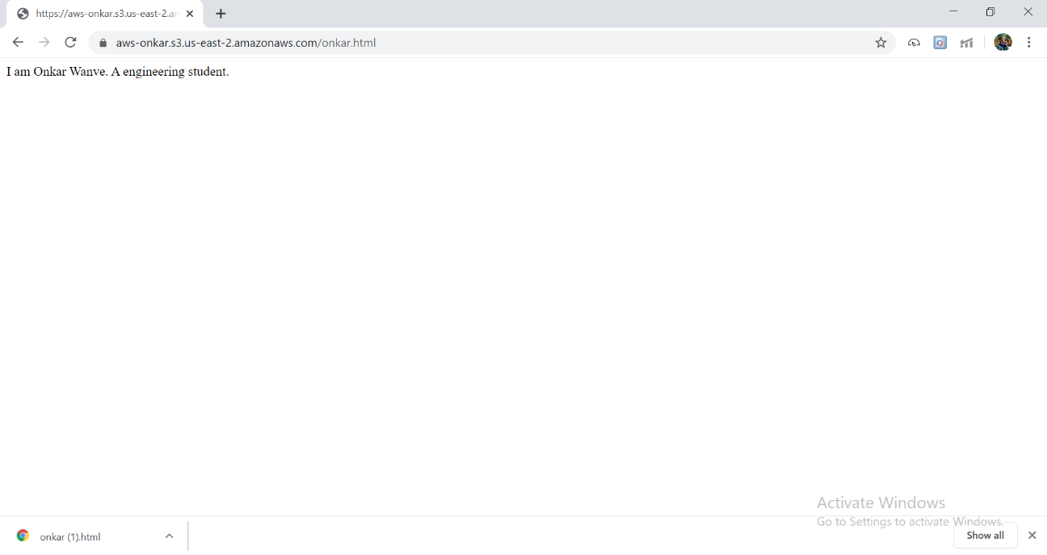

SCREENSHOT OF RECOGNITION:

1.Face Detect:

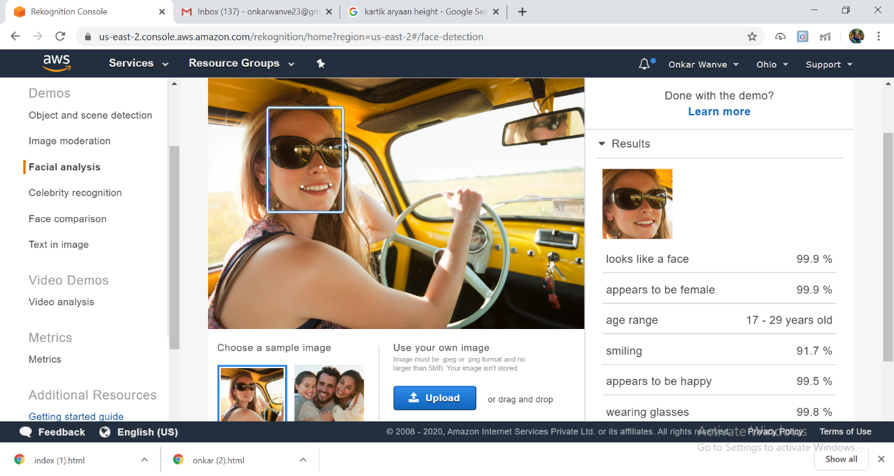

2.Face Compare:

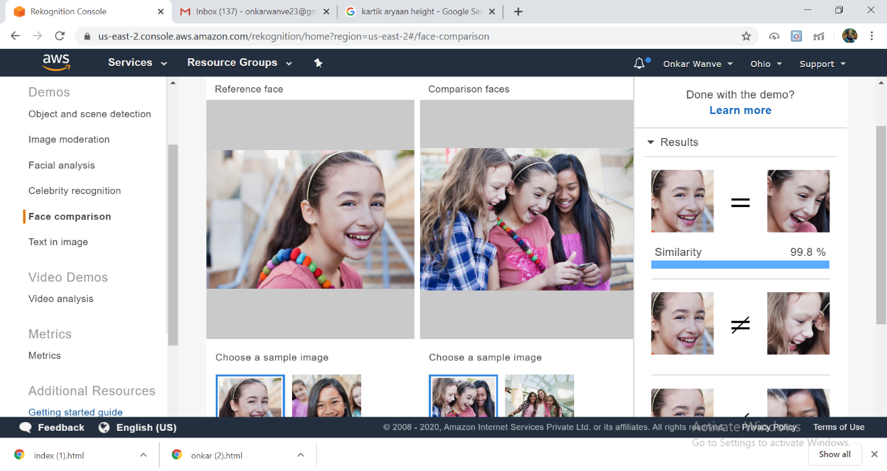

3.Celebrity Recognition:

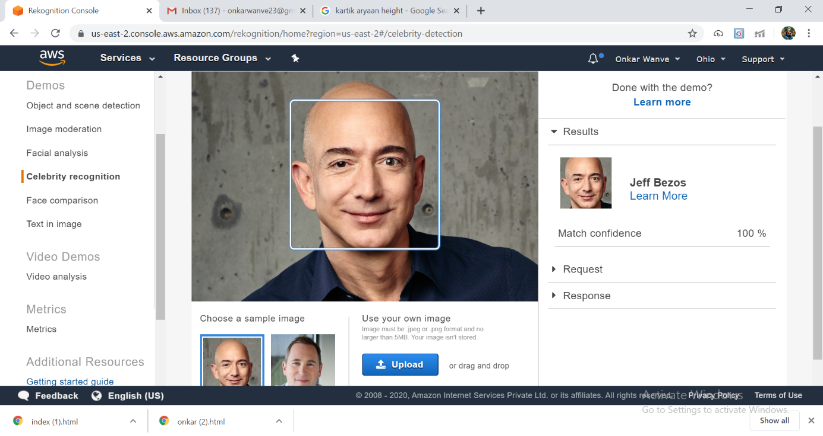

4.Text in Image:

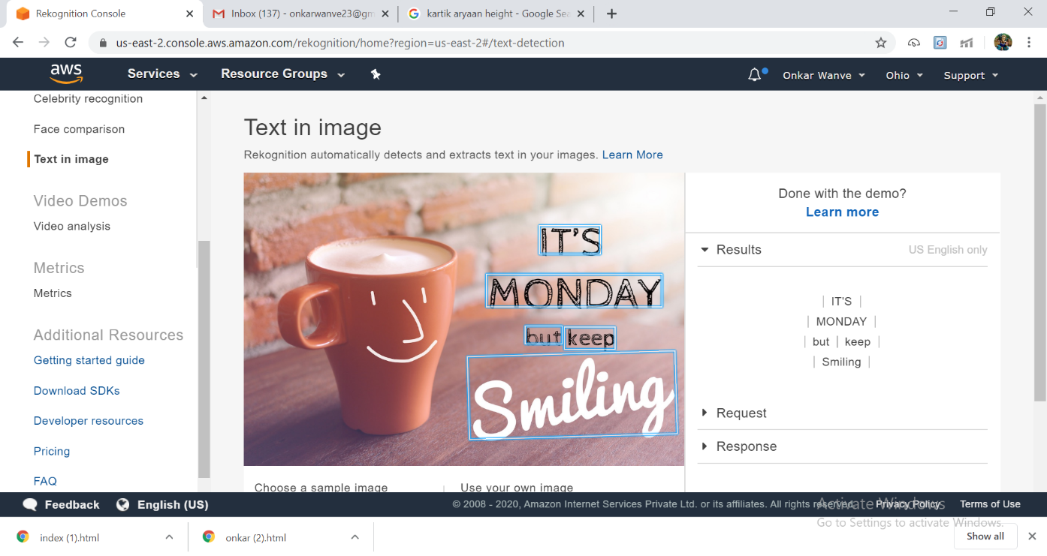

SCREENSHOT of S3

1.Installing aws-sdk:

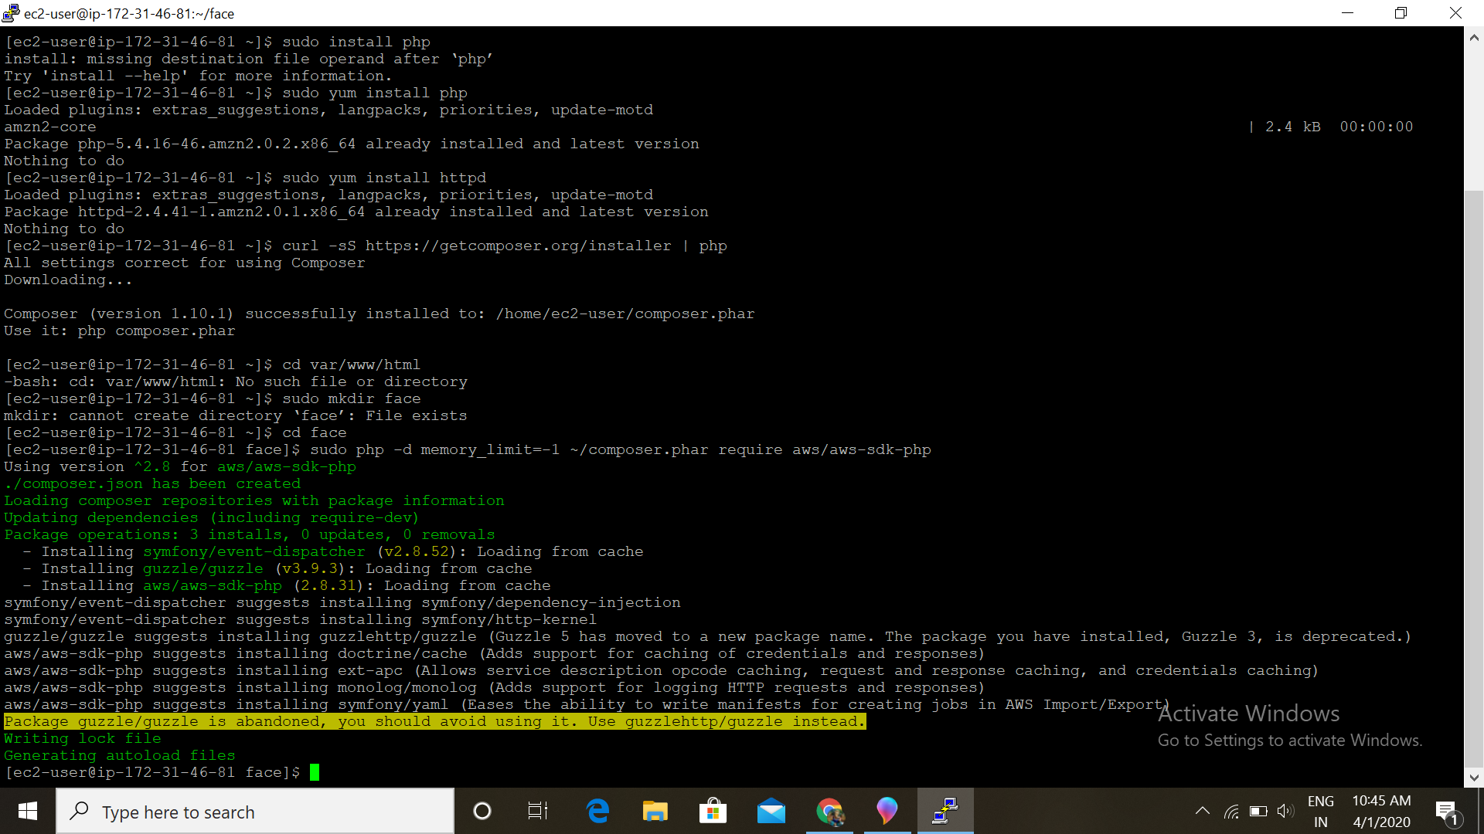

2.Installing php:

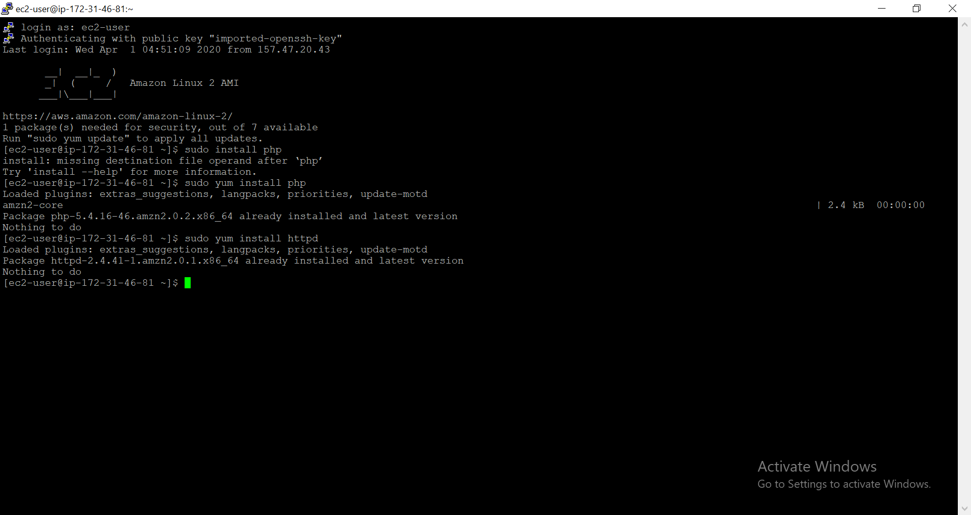

3.Index.php file code:

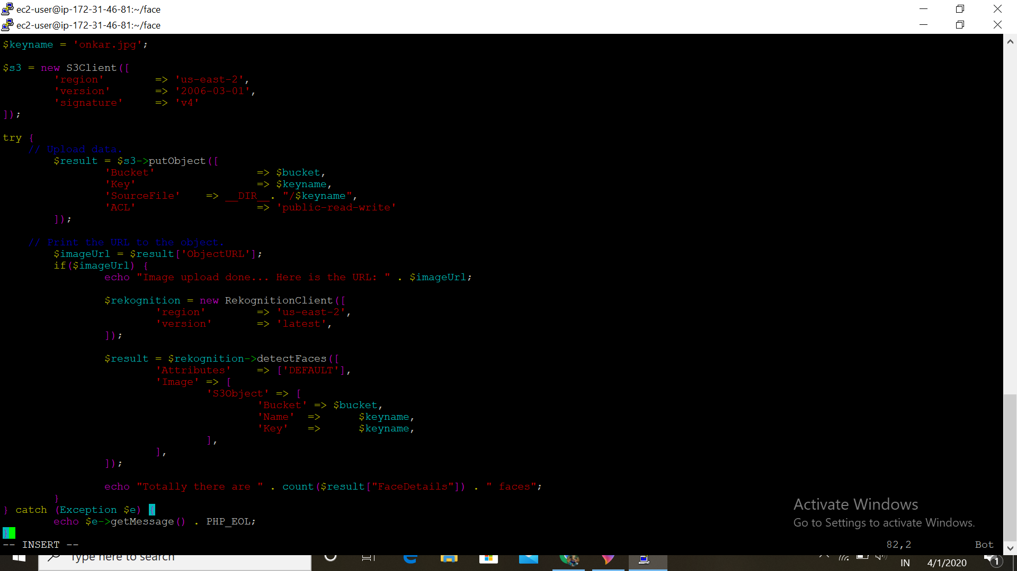

4.Upload Success Screenshot:

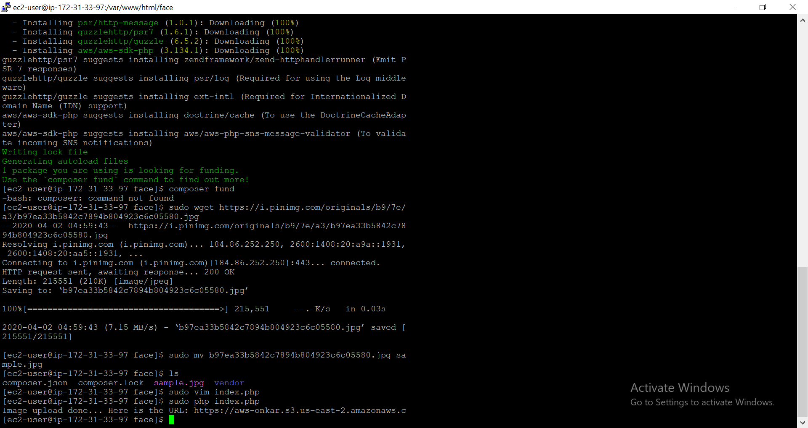

SCREENSHOT NEEDED FOR EC2 &RECOGNITION

1.Face detect success Screenshot:

